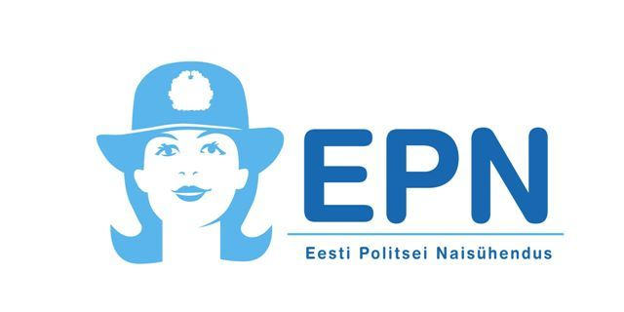

Daily program:
Friday 18th July
15.00 | Arrival and registration (with possibility to buy IPA souvenirs).
 | Free time with possibility to grill on the grill site. Athletes may get
 | into the theme.
Saturday 19th July
08.00 | Breakfast
10.00 | Opening of the Summer Days
10.30 | Games in search for a hedgehog WNEP women deal with
 | children.
13.00 | Launch
14.00-15.00 | Free time
15.00-17.30 | Games continue on the paths of the Epic
18.00 | Supper
20.00 | Dance evening
Sunday 20th July
09.00 | Breakfast
11.00 | Festive closing with flag lowering and line-up
12.00 | Wrap tents, things, say good-bye and leave.

On Friday evening It is possible to buy warm food from the Buffet (price 7€). You can grill only in places intended fot it, outside specially intended places grilling is not allowed. There is a bar in the main building where you can buy cask beer (1,50€) and cyder (2€), also sweets, soft drinks and ice cream. You can pay in cash or using credit card. For relax at your disposal Finnish sauna, smoke sauna and cask sauna.

Additional information from the main buliding or from event organizers (phone:)
+37253497061 – Karl
+3725287777 - Enn

