INTERNATIONAL POLICE ASSOCIATION
SECTION ITALY – REGION 17 Friuli
LOCAL BRANCH
“LIGNANO BASSO FRIULI”
lignano sabbiadoro (udine) - italy
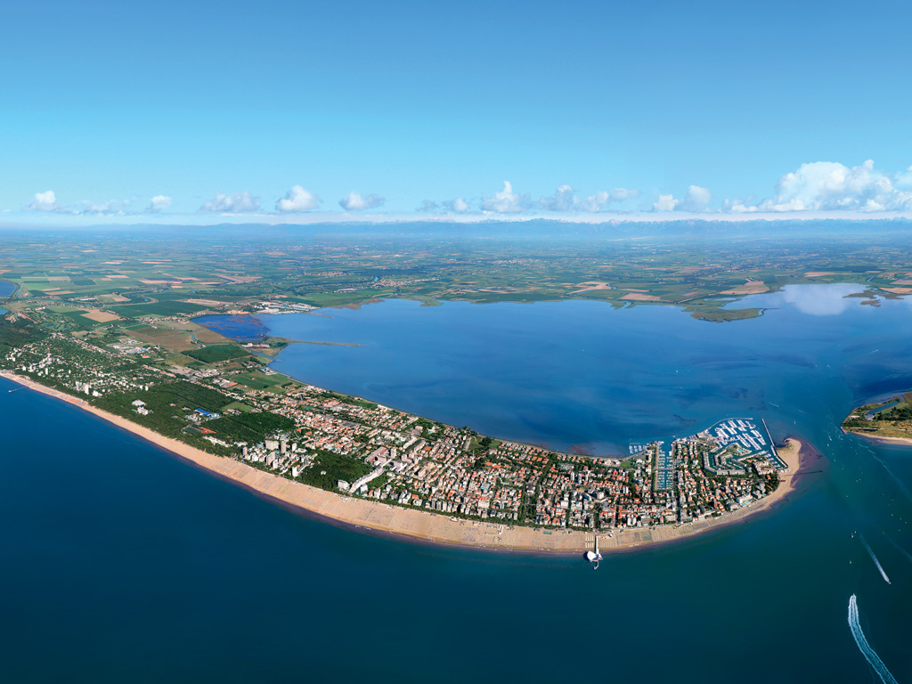
I.P.A. CENTENARY MOTORCYCLE RALLY
“MEMORIAL michele filippo”
Lignano Sabbiadoro, 22-23-24-25 september 2016

Program:
1° day – Thursday 22nd of September 2016
- Afternoon: arrival of the guests at Lignano Sabbiadoro, Hotel COLUMBUS****, Lungomare Trieste 22,<www.doimohotels.it> , check-in;
- 7,00 p.m. welcome cocktail;
- 8,00 p.m. dinner and overnight stay at the Hotel.

2° day – Friday 23rd of September 2016
- breakfast at the Hotel;
- 9.30 a.m. departure by feet from the hotel to the docks and boarding the ship Saturno, boat tour of the Marano lagoon and the river Stella, lunch on board and in one of the traditional huts of the lagoon;
- approx. 4,00 p.m. return to the Hotel and free time for shopping;
- 8,00 p.m. dinner and overnight stay at the Hotel.

3° day – Saturday 24th of September 2016
- 7.00 a.m. breakfast at the Hotel
- 8.00 a.m. meeting of the participants at the square of the town hall of Lignano Sabbiadoro - Viale Europa 26;
- 8.30 a.m. welcome speech of the Mayor of Lignano Sabbiadoro and laying of a wreath at the monument of the fallen soldiers;
- 9.00 a.m. departure with the motorcycles with the following intinerary: Lignano Sabbiadoro, Latisana (Crosere), Palazzolo dello Stella, Muzzana del Turgnano, S.Giorgio di Nogaro, Torviscosa, Cervignano del Friuli, Villa Vicentina, Pieris, S. Pier d’Isonzo, REDIPUGLIA - 68 km;
- 11-11.30 a.m. short break at the monument of Redipuglia and laying of a wreath in honour of the 100.000 soldiers fallen during the 1st World war;
- 11.40 a.m. departure from Redipuglia – Sagrado, Gradisca, Palmanova, Gonars (short break for laying flowers on the grave of the Carabiniere and motorcyclist Michele Filippo), Rivolto, Villa Manin di Passariano;
- 13.00 p.m. break at Villa Manin at Passariano for lunch (buffet) at the restaurant Nuovo Doge;
- After lunch, return to the hotel via Codroipo, Latisana (Crosere) – 95,2 km
- 8.00 p.m. dinner and Gala-evening at the hotel, overnight stay.

4° day – Sunday 25th of September 2016
- 8.00 a.m. breakfast at the hotel
- 9.00 a.m. greetings and departure of the guests.

The participation fee includes:
OPTION 1: 4 DAYS-3 NIGHTS: €uro 220,00 per person
- participation fee
- welcome cocktail
- 3 overnight stays in double room, hotel ****
- full board, as for the programme, from the dinner on 22/9 until breakfast on 25/9 (Gala-evening included)
- drinks at meals (wine, water, coffee)
- boat trip to the lagoon of Marano with the ship Saturn and lunch on board
- assistance during the stay
- parking for the motorcycle in the garage of the hotel.

OPTION 2: 3 DAYS – 2 NIGHTS: €uro 160,00 per person
- participation fee
- 2 overnight stays in double room, hotel ****
- full board, as for the programme, from the dinner on 23/9 until breakfast on 25/9 (Gala-evening included)
- drinks at meals (wine, water, coffee)
- assistance during the stay
- parking for motorcycle in the garage of the hotel.

OPTION 3: MOTORCYCLE RALLY ONLY: €uro 40,00 per person
- participation fee
- lunch on 24/9
- assistance during the route.

OPTION 4: GALA-EVENING ONLY: €uro 35,00 per person

The fee does not include:
- Supplement for single room € 15,00 each night per person
- fuel for the motorcycles
- any necessary parts for repairs
- Extra drinks and meals not included in the program
- Anything which is not described in the program.
NOTES:
- €uro 100.00 per person required as deposit to confirm the reservation to be sent by bank transfer. RE: I.P.A. CENTENARY MOTORCYCLE RALLY 2016: Mr/Mrs _________________
Bank details:
CREDIFRIULI-CREDIT COOP FRIULI
CERVIGNANO OFFICE OF FRIULI (UD)
IBAN: IT95Y0708563730000210007183
BIC CODE: CCRTIT2TK00
- Copy of the registration form, duly completed and signed, to be sent together with copy of the bank wiring receipt to cortese.p@alice.it by 30 June 2016.
- Balance of payment due by 31 July 2016.
- In case of cancellation of the participation, there will applied the economic rules, provided for in Itay, by the travel agencies.
- Reservations will be accepted pending places available in hotels (400)

THE ORGANIZATION:
- We reserve the right to make changes to the program, which will be communicated to
the participants, maintaining the quality and the services offered;
- We can not be held liable for any accidents in the routes planned or infringements of the code of the road occurred or committed by participants;
- For information on the path of the Motorcycle rally, please contact: Giuseppe Patané tel.
+39 346 1872580 E-Mail pino1251957@libero.it
- For reservations or information about your stay, please contact: PASQUALE CORTESE Tel
+39 0431.371238 +39.3381705198 E.Mail cortese.p@alice.it

SERVO PER AMIKECO

