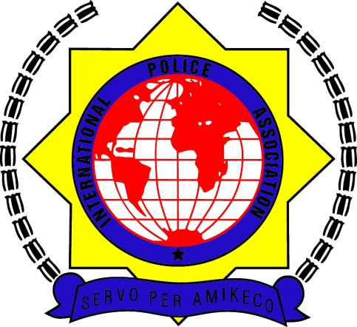
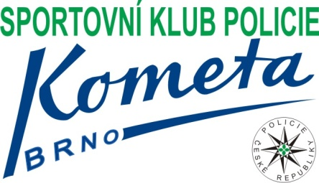
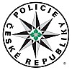

INTERNATIONAL POLICE ASSOCIATION

CZECH REPUBLIC

TERRITORIAL GROUP 201 BRNO

XIV.

BRNO CUP 2016

IN SMALL SOCCER

BRNO, CZECH REPUBLIC

NOVENBER 25 ^{th} 2015
Dear colleagues,
Let me invate you in name of INTERNATIONAL POLICE ASSOCIATION CZECH REPUBLIC region group 201 Brno and CZECH POLICIE FORCE, for XIII. Annual international tournament in small soccer - BRNO CUP 2015, traditionally in Brno , in dates NOVEMBER 25th 2016.

We will be happy if you come.

With regards,
Head of IPA 201 BRNO
Mgr. Pavel Fiala

Registration
The tournament is set for max. 16 teams from different district groups IPA. If you want participate in our tournament, please send your registration before end of 30th SEPTEMBER 2016.

Post Address: Contact person:

KRAJSKÉ ŘEDITELSTVÍ POLICIE

JIHOMORAVSKÉHO KRAJE Mgr. Pavel Fiala

IPA Brno No 201 GSM: +420 602541754

Kounicova 24, 611 32 BRNO TEL: +420 974621212

FAX: +420 974 623 728
E-MAIL: brnoipacup@gmail.com

Price
Each team will pay the entry fee of 1500, - CZK (60,- EURO) for a number of up to 10 people. For each additional person 150, - CZK (6,- EURO). Price includes the organization, the cost of refreshments for the tournament and awards ceremony.
Entry fee will be paid in cash immediately before the commencement of the tournament.
Payment of the entry fee is a necessary condition for participation in the tournament.

Accommodations
Tournament participants can provide their own accommodation
For example, the possibility of accommodation:
Orea Hotel Voroněž II Brno, Křížkovského 47, Brno,
www.orea.cz/voronez2, tel. +420543142020, fax. +420543211966
e-mail: voronez2@voronez.cz
Sports complex is located about 5 km from the hotel

HOTEL VISTA, Brno, Hudcova 72, Brno
www.vistahotel.cz, tel. +420541217088, fax. +420541245569
e-mail: info@vistahotel.cz
Sports complex is located about 1,5 km from the hotel

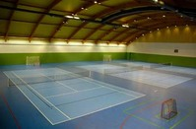
Sports Hall VUT Brno, ul. Technická č. 14

Program
25.11.2016 - friday

- 08.00 - 09.00 hod departure of participants to the sports hall
- 09.00 - 09.05 hod line up of the teams, the opening ceremony
- 09.15 - 14.30 hod soccer matches
- 15.00 - 16.00 hod announcement of the results
- 16.00 free program

Eventuall change of the program will be announced

Rules
- play system will be in connection of number of teams
- Soccer rules apply with minor adjustments
- The team includes four field + one goal keeper, the number of substitutes is arbitrary
- Rotation is free at the touch line
- The match is 15 minute running time period, a change id possible
- The referee terminates the game at his discretion
- The penalty kick starts on the forwarding team’s half of the playing field after the sound of referee’s whistle
- Yellow card means two penalty minutes
- Red card means two penalty minutes and the punished player is out of game till the end of the game, eventually he could be disqualified for other games as well (the director of the tournament is in charge with this decision)
- A kick-in is taken from the touch line when the ball crosses a sideline and leaves the field
- “Accumulated penalty kicks” are established. Committing of four fouls means, that each next foul will be punished by penalty kick without “protection wall”
- Grabbing of the opposite player or his dress will be judged very strictly
- Each time the ball is kicked in (penalty kick, touch line kick-in, corner kick) the players have to keep at a distance 5 meters form the ball
- A pass to the goalkeeper is allowed, however, the goalkeeper may play only with his feet (he can’t use his hands)
- The goalkeeper throws the ball off from the goal with his hands even over the half playground line
- The goalkeeper may kick the ball off only if he catches the ball during the game
- The director of the tournament can disqualify the player or the team for unfair behavior (assault of the refree, insidious cruel playing, row between the players and so on)
Points:
- win 3 points
- draw 1 point
- loss 0 point

The following criteria are used to determine the placement in-group:
1. higher number of points
2. match of the teams in question
3. greater score difference
4. greater score ratio
5. additional penalty kicks

In the case of the same points score of more than one team the score of their mutual matches is decisive

Protest : The protest may be brought immediately (at latest 30 minutes after the match) by the director of the tournament. The caution is 500,- Kc.
List of registration

Names of teams

Number of person

surname | firstname | birthday

Team´s leader:
Contact:

Sports Hall
Sports Hall VUT Brno, ul. Technická č. 14

Mahen’s Theatre Constitutional court

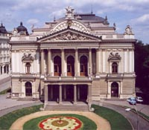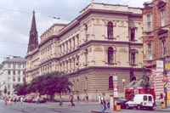

Castle „Spilberk“ Castle „Spilberk“

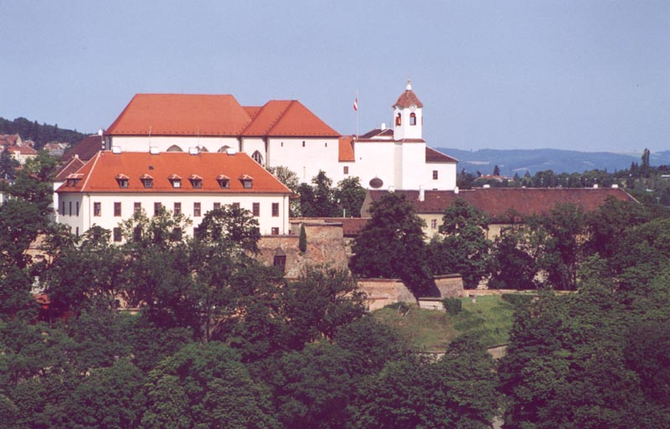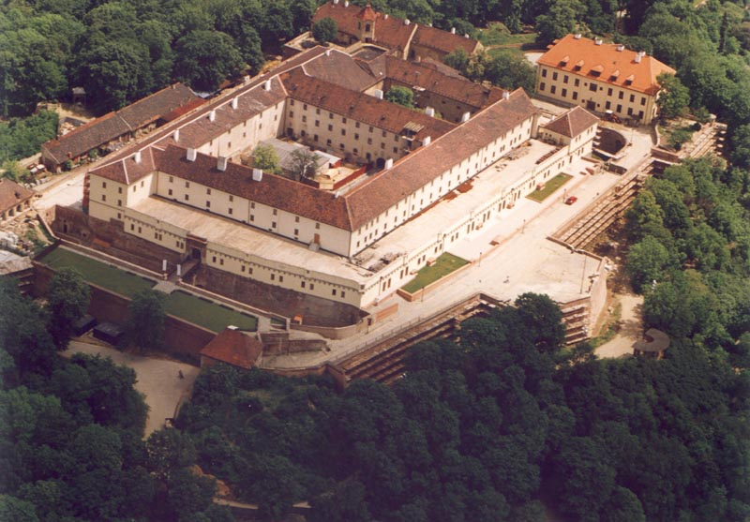

Church St. Peter and Paul

