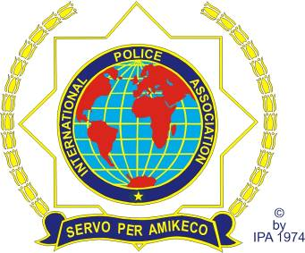 | INTERNATIONAL POLICE ASSOCIATION  SECTION SLOVENIA  3000 Celje, Ljubljanska cesta 12  www.ipaslovenija.org  e-mail: ipa_slovenia_lipnik@siol.net

Rimske Toplice, February 2nd, 2016

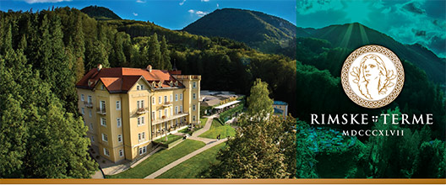

http://www.rimske-terme.si/sl/

25 YEARS OF THE IPA INTERNATIONAL POLICE ASSOCIATION
SECTION SLOVENIA
Rimske Toplice, Hotel Rimske terme
April 8th to April 10^{th,} 2016

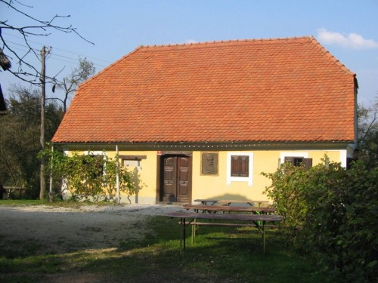
Aškerc's homestead

Dear IPA friends!

You are cordially invited to the celebration of the 25th anniversary of the IPA Section Slovenia, which will take place from April 8th to 10th in the hotel and congress centre Rimske terme, Toplice 10, Rimske Toplice.

Our section was established 25 years ago, on April 20th, 1991. This anniversary will be celebrated in the hotel and congress centre Rimske terme.

You are invited to join us.

PROGRAMME
OF THE 25TH ANNIVERSARY OF THE IPA SECTION SLOVENIA,
Rimske Toplice, Toplice 10, hotel and congress centre Rimske terme,
from April 8th to 10th, 2016

Friday, April 8th, 2016
- until 17.00 arrival of the foreign delegations and guests,
- at 18.30 welcome, greetings from the President of the IPA
Section Slovenia,
- at 19.00 dinner at the hotel.

Saturday, April 9th, 2016
- from 7.00 to 9.00 breakfast at the hotel,
- from 10.00 to 11.00 arrival of the participants to the ceremonial academy,
- at 11.00 ceremonial academy at the congress centre Rimske
terme,
- at 13.00 lunch at the hotel,
- at 15.00 walk to the Aškerc’s homestead, tour of the farmhouse
and degustation,
- from 17.00 to 19.00 leisure activities,
- at 19.00 gala dinner at the hotel with music.

Sunday, April 10th, 2016
- from 7.00 to 9.00 breakfast at the hotel and departures.

PRICE: 150€ per person, which includes:
- the full programme of the celebration,
- accommodation (in a double room) and meals at the hotel,
- use of the swimming pool and saunas,
- a memorial gift,

SURCHARGES:
- single room 10,00 € per person per day.

DEADLINES AND PAYMENTS: Tuesday, March 15th, 2016

REGISTRATION: on the enclosed form.

Any additional information and applications to be addressed to:

Secretary General of the Section
Istvan LIPNIK
Štrihovec 73
2212 Šentilj v Slovenskih Goricah
Slovenija
e-mail ipa_slovenia_lipnik@siol.net
mobile phone: 00386 41 468 404

or

Treasurer of the section
Alojz HRNČIČ
Migojnice 81 b
3302 Griže
Slovenija
e-mail: alojz.hrncic@triera-net

METHOD OF PAYMENT:
to the account of the IPA, International Police Association, Section Slovenia, namely:

BANK ACCOUNT DETAILS:

BANK NAME: Nova Ljubljanska banka d. d.
BANK ADDRESS: Trg Republike 2, 1520 Ljubljana
ACCOUNT NAME: poslovni račun
ACCOUNT DETAILS: SI56022330254077144
IBAN CODE: SI56022330254077144
BIC CODE: LJBASI2X

Early arrivals or late departures can be arranged. The cost of each additional day is charged according to the price list of the hotel.

SERVO PER AMIKECO

Stanislav FICKO
PRESIDENT

INTERNATIONAL POLICE ASSOCIATION
SECTION SLOVENIA
3000 Celje, Ljubljanska cesta 12
www.ipaslovenija.org
e-mail: ipa_slovenia_lipnik@siol.net

APPLICATION FORM

Rimske Toplice, Toplice 10, Rimske terme, April 8th to April 10th, 2016

(mark all that apply)

1. APPLICATION FOR THE COMPLETE PROGRAMME yes no

NAME _________________________ SURNAME __________________________

ADDRESS __________________________________________________________

TEL. ____________________ e-mail: _________________________________

IPA SECTION: ____________________ COUNTRY: _________________

TRAVELLING WITH ME (companion):

NAME _____________________________ SURNAME _______________________

ADDRESS___________________________________________________________

ROOM: SINGLE ( _____) DOUBLE ( _____)

DEADLINE FOR APPLICATION AND PAYMENTS: Tuesday, March 15th, 2016

BANK ACCOUNT DETAILS:

BANK NAME: Nova Ljubljanska banka d. d.
BANK ADDRESS: Trg Republike 2, 1520 Ljubljana
ACCOUNT NAME: poslovni račun
ACCOUNT DETAILS: SI56022330254077144
IBAN CODE: SI56022330254077144
BIC CODE: LJBASI2X

Date: _________________ SIGNATURE

____________________

