THE DAYS OF FRIENDSHIP WEEK FOR IPA POLICE WOMEN
IN ST. PETERSBURG, RUSSIA
5-9 June 2016

Dear Heads of Section IPA!!

The St. Petersburg region of the IPA Russian section wish to invite and welcome you to Friendship Week for IPA Police Women. On behalf of the Travel Secretary of the Russian IPA section, Vice-President of the St. Petersburg region and Vice President for Culture, Olga Birkina we welcome you between 5th to 9th June 2016, to the cultural capital of the Russian Federation!

On 5th June 2016, after the end of the First International Festival for professional and creative skills among female members of the IPA, held in Moscow, Russia. The participants of the IPA Friendship week together with me will take a bus to Moscow’s Leningrad station, where we will take the Sapsan bullet train to St. Petersburg. We depart at 11:30 and will arrive in the northern capital in around 4 hours and15 minutes.
On 5th June at 16:15 on arrival in St. Petersburg, we will take a bus to the Elizar Hotel and for 5 days and 4 nights enjoy the cultural capital's amazing artistic offerings!
During the 5th June 2016, guests from other countries will arrive at the Elizar Hotel for the IPA’s Friendship Week for IPA Police Women. Guests will be met at Pulkovo airport and this is being provided by volunteers, young members of the IPA, who will take our visitors by car to the hotel. Members of the IPA St. Petersburg region will be actively involved.

Any visa required for your stay in Moscow and St. Petersburg Russia should be from at least 31st May to 10th June 2016.

You will need to provide as soon as possible:
1. Registration Form.
2. A copy of two passport pages (main page and visa).
3. A copy of your IPA Membership card.

Please submit by 01.03.2016 by email to: kultura.spb.ipa.2015@mail.ru
Payment details are in with the application form and the total cost is €420 per person, payment is requested by 10.03.2016

Please feel free to get in touch with any questions.
Note:
- Russia uses the standard European plug system.
- You will receive a full program of events by email.
- We aim to fulfil any individual requests with the help of the Russian police!

Annex to the Invitation:
1. Registration Form - 1 sheet,
2. Bank account details (Euros).

All the best and see you soon in Moscow and St. Petersburg, Russia!
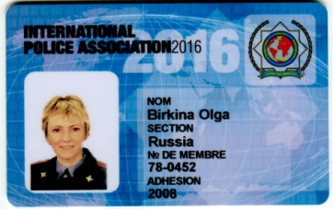
Yours Sincerely
Olga Birkina.
Tel: +79119140505
https://www.facebook.com/olga.birkina
http://rusipa.ru/?page_id=4678

