THE PROGRAMM
MAY WEEK
for 04-10 May 2016
Wednesday  04 May | 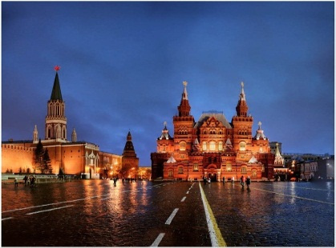  Meeting at the airport.  19-00 Arriving at the Hotel  20-00 Supper
Thursday  - May | Breakfast  10-00 The Museum of cosmonautics  12-00 Meeting with an astronaut  14-00 dinner  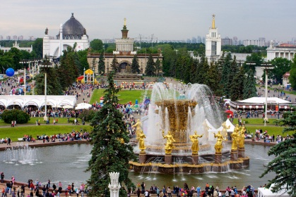  15-00 VVC All-Union exhibition of achievements  free time  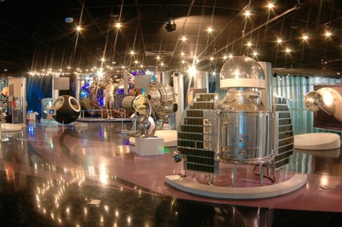  20-00 Supper
Friday  06 May | 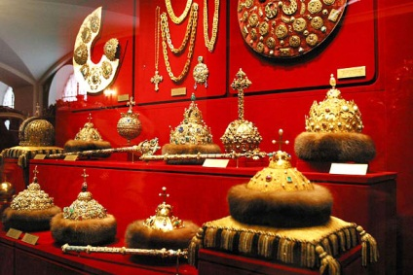  Breakfast  10-00 Museum, the Kremlin  12-00 The Diamond Fund  14-00 Dinner (Russian restaurant)  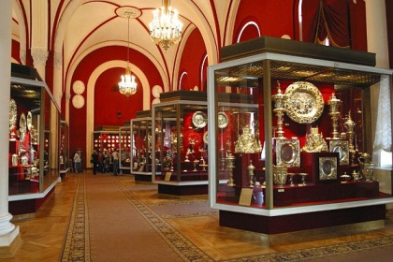  16-30 Armoury Chamber  19-00 Supper  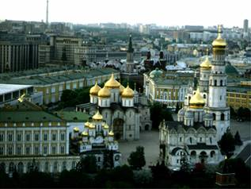
Saturday  07 May | 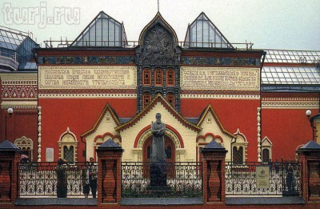  Breakfast  10-30 Tretiakovskaya Gallery  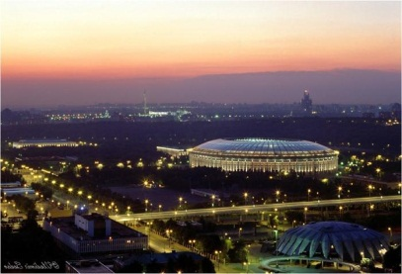  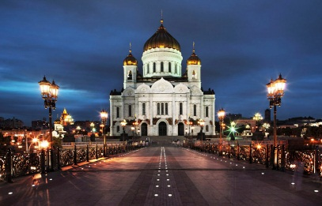  14-00 Dinner  15-00 The Cathedral of Jesus Christ  16-30 Sightseeing tour of Moscow  20-00 Supper
Sunday  08 May | 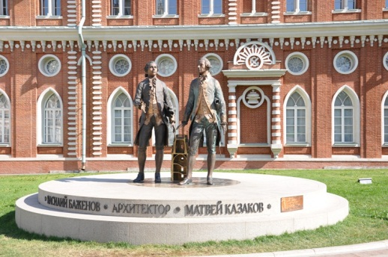  Breakfast  12-00 to 18-00  The Museum reserve Tsaritsyno or  Boat trip  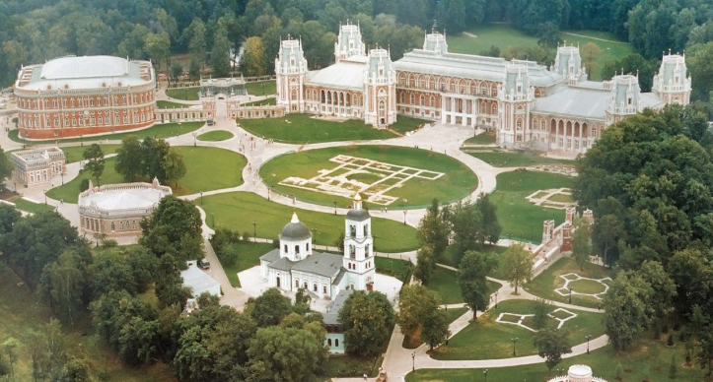  14-00 Dinner  18-00 Free time  20-00 Supper  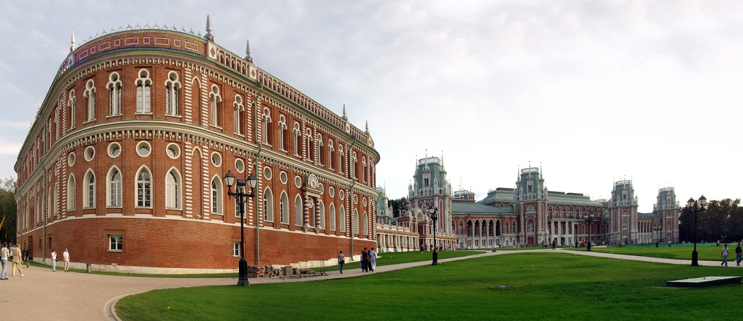
Monday  09 May | 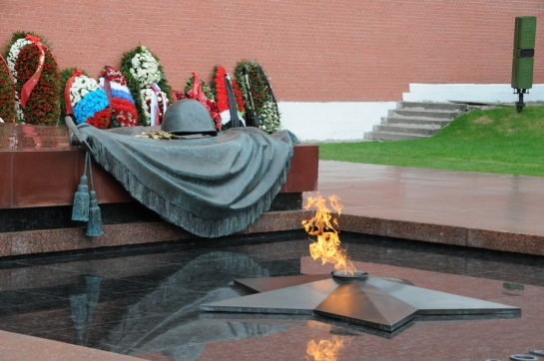  Breakfast  10-30 The ceremony of laying flowers to the monument of the  unknown soldier.  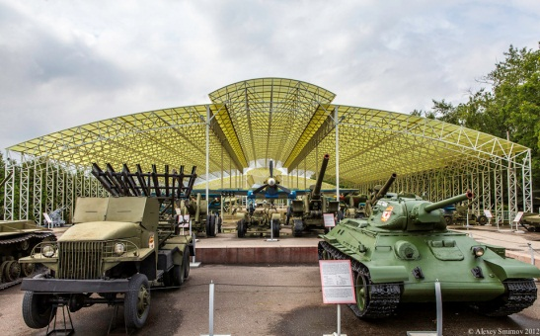  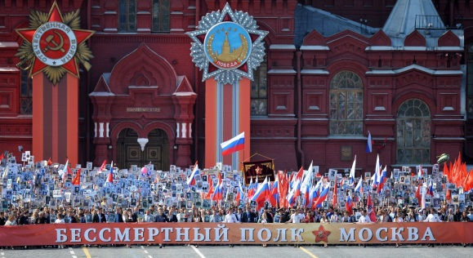  11-00 Red Square, the changing of the guard, immortal regiment  14-00 Dinner  15-30 The museum of Great Patriotic war.  17-00 The Poklonnaya hill. Red fauntains  20-00 Gala supper  22-00 Victory Salute
Tuesday  10 May | 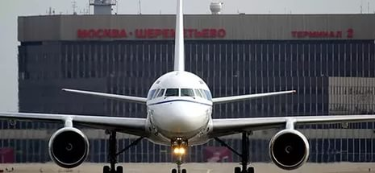  Breakfast  Transfer to the Airport

