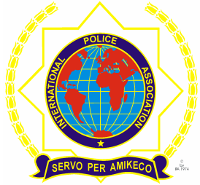 | INTERNATIONAL POLICE ASSOCIATION (IPA)  MOSCOW REGION  www.mosipa.ru
REGISTRATION FORM

MAY WEEK in MOSCOW

(4 – 10 May 2016 года, Moscow)

SURNAME …………………. FORENAMES………………
Address (Including Postcode):

National Section:
E-mail address:
Tel.№: Mob:
Landuage: English
French
German
Spanish

ACCOMMODATION
Double room sharing with
Single room

ARRIVALS/ DEPARTURES
Date & Time of Arrival: May2016 Airport:
Date & Time of Departure: May 2016 Airport:

PRICE PER PERSON:
Double - 825 Euro
Single - 960 Euro

The registration form must be completely filled, the reservation has been paid and sent to us (mosipa@mail.ru) before March 30/2016

