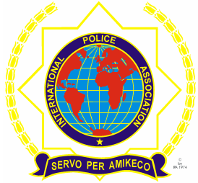 | INTERNATIONAL POLICE ASSOCIATION (IPA)  MOSCOW REGION  www.mosipa.ru
REGISTRATION FORM
«MAYSKAYA» WEEK IN MOSCOW

(08 May – 13 May 2017, Moscow)

SURNAME …………………. FORENAMES………………
Address (Including Postcode):
National Section:
E-mail address:
Tel.№: Mob:
Language: English
French
German
Spanish

ACCOMMODATION
Double comfort Suite double comfort
Single comfort Suite single comfort

ARRIVALS/ DEPARTURES
Date & Time of Arrival: May 2017 Airport:
Date & Time of Departure: May 2017 Airport:

PRICE PER PERSON:
Double comfort - 790 Euro Suite double comfort - 880 Euro
Single comfort - 845 Euro Suite single comfort - 925 Euro

The registration form must be completely filled, the reservation has been paid and sent to us (mosipa@mail.ru) before March 01/2017
***The organizers reserve the right to make changes to the program maintaining the quality of services offered.

