INTERNATIONAL POLICE ASSOCIATION (IPA)
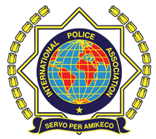

Неправительственная организация

с консультативным «Special» Статусом в Экономическом и Социальном Совете ООН; с консультативным Статусом в Совете Европы и Организации Американских государств;

международная неправительственная организация, сотрудничающая

с ЮНЕСКО и Европолом
NGO in Consultative (Special) Status with the Economic and Social Council of the United Nations; in Consultative Status with the Council of Europe and the Organization of American States; International NGO maintaining operational relations within UNESCO and Europol

« RUSSIAN SECTION IPA»
(Registered Ministry of Justice of the Russian Federation, OGRN 1087799001993)
Russia, 190005, St. Petersburg, ul. 7th Krasnoarmeyskaya, 26, lit.Б
T / f 8 (812) 6900505, +7 911-914-05-05
www.rusipa.org E-mail: kultura.spb.ipa.2015@mail.ru

INVITATION

25th Anniversary Celebration (Friendship week)
IPA Russian Section, St-Petersburg, Russia

Dear IPA Friends,

It’s a great honour for us to invite IPA members to participate in a cultural event – “Neva’s Week of Friendship”, Saint-Petersburg, devoted to the celebration of the 25th anniversary of Russian IPA section.
Children of IPA members, aged above 18, are invited on special discount basis.
You’ll be our wished guests during all the days of your staying in Saint-Petersburg. We are waiting for your registration forms and your passport copies till July, 20, 2017, to have enough time for organizing your visa support.
Payments for participation in “Neva’s Week of Friendship” are requested to be done till July, 25, 2017 for the enclosed bank account.
In case you participate in Jubilee Conference of IPA for the period of September 07-10, 2017, please, note in participant’s registration form the dates for required visa as the period of September 07 – 15, 2017. Type of visa is tourism. You’ll receive hotel’s voucher in the nearest time. (Central Moscow office of Russian IPA section is responsible for it).
Participants of the cultural event “Neva’s Friendship Week” need to put in participant’s registration form the following dates for visa’s period required– September, 10-15, 2017. Type of visa is tourism. You’ll receive hotel’s voucher in the nearest time. (Saint-Petersburg’s Regional Russian section of IPA, Cultural Department is responsible for it.)
All the participants of the Jubilee Conference of IPA and “Neva’s Week of Friendship” will be accommodated in “Okhtinskaya” hotel, Saint-Petersburg.
We’ll be glad to meet you in Saint-Petersburg.

All the information, given above, has been agreed with the president of Russian IPA section – Aleksey Gankin.

SERVO PER AMIKECO!

Organiser,
Travel-Secretary of Russian IPA section
Vice-president of Cultural Department of
Saint-Petersburg’s Regional section of IPA O.V.Birkina

PROGRAM

25th Anniversary Celebration (Friendship week)
IPA Russian Section, St-Petersburg, Russia

10.09.2017 – 15.09.2017

Sunday, 10/09/2017
Arrival of the participants Pick up from the Airport Hotel accommodation
14.00 Lunch at the hotel
15.30 sightseeing tour
18.30 dinner
19.30 free time at the hotel
00.00 – tour to AURORA, Smolny, Palace Squere Breeding of the bridge

Monday, 11/09/2017

08.00- 09.30 Breakfast at the Hotel “OHTINSKAYA”

10.00 - trip to Konstantinovsky Palace
14.30 – Lunch in Restaurant (national kitchen
13.00 -14.00 Lunch
15.00 - Peterhof
18.30 – Dinner at the Hotel

Tuesday, 12.09.2017
07.30-09.00 – Breakfast at the Hotel
10.00 – traffic police museum
13.00 – Lunch in restaurant Schelkunchik
15-00 – 18-00 Hermitage museum
18.00 – Dinner at the Hotel

WEDNESDAY, 13.09.2017

07.30 - 09.00 Breakfast at the Hotel “OHTINSKAYA”
10.00 Departure to the Pavlovsk
14.00 – 15.00 Lunch
15.00 – 18-00 Puschkin. Alexander garden
19.00 – DINNER at the restaurant in Puschkin town
20.30 free time at the hotel

TURSDAY, 14.09.2017
08.00 - 09.00 - Breakfast
11.00 – 12.00 Peter-Pavels Fortress
13.00 – Restourant Schelkunchik
14.30 - Shopping
18.00-21.00 Gala Dinner at the Hotel
FRIDAY, 15.09.2017
07.30 – 09.00 Breakfast
Departure of the participants

РЕГИСТРАЦИОННАЯ ФОРМА
REGISTRATION FORM

Jubilee’s “Neva’s Week of Friendship” for IPA members
In Saint-Petersburg, Russia, September 10-15, 2017

ФАМИЛИЯ/ SURNAME __________________________________________________________________________________
ИМЯ/ NAME ____________________________________________________________________________________________
ОТЧЕТСВО/ MIDDLE NAME_________________________ Должность МПА/ Position IPA _________________________
ДАТА РОЖДЕНИЯ/ DATE OF BIRTH______________________________ПОЛ/ MALE/FEMALE____________________
ГРАЖДАНСТВО/ CITIZENSHIP___________________________________________________________________________
НОМЕР ПАСПОРТА/PASSPORT NUMBER_________________________________________________________________
ДАТА ВЫДАЧИ/ DATE OF ISSUE_________________________________________________________________________
ДАТА ОКОНЧАНИЯ СРОКА ДЕЙСТВИЯ/ EXPIRY DATE____________________________________________________
ГОСУДАРСТВО, МЕСТО РОЖДЕНИЯ/ STATE, PLACE OF BIRTH_____________________________________________
МЕСТО РАБОТЫ И АДРЕС/ PLACE OF WORK AND ADDRESS ________________________________________________________________________________________________________
НАЗВАНИЕ ГОРОДА ПОСЕЩЕНИЯ В РОССИИ/ NAME CITIES OF VISIT IN RUSSIA___________________________
№ТЕЛЕФОН/ TELEPHONE NUMBER ______________________________Е-MAIL: ______________________________
ВИЗА / VISA
ВЫДЕЛИТЬ НЕОБХОДИМОСТЬ ПОЛУЧЕНИЯ ВИЗЫ / UNDERLINE VISA’S NECESSITY
VISA - да/ yes нет/ no

БЛАНК РЕГИСТРАЦИОННОЙ ФОРМЫ ПОДГОТОВЛЕН ДЛЯ ПОЛУЧЕНИЯ ВИЗЫ, ОФОРМЛЕНИЯ ОФИЦИАЛЬНОГО ПРИГЛАШЕНИЯ И ПОЛУЧЕНИЯ ВИЗОВОЙ / REGISTRATION FORM IS ELABORATED FOR OFFICIAL INVITATION PAPER FOR VISA’S SUPPORT.

1. ПРИБЫТИЕ/ARRIVAL:
Arriving at the Airport "PULKOVO" St. Petersburg. Waiting for your IPA bus. Delivery To the hotel "Okhtinskaya", address: Bolsheokhtinsky prospect, 4.
*****************************************************************************************
ПРИБЫТИЕ/ARRIVAL:

1.АРОПОРТ/AIRCRAFT - Russia, St. Petersburg, Pulkovo

Дата/ Date _____________ Время/ Time __________________ Номер рейса/ Flight number _____________________

*****
2.ПОЕЗД № /Train №._________________________________ Вагон/ Coach №._________________________

Дата /Date _____________________ Время прибытия /Time of arrival ________________________________________

УБЫТИЕ/ DEPARTURE:
АРОПОРТ/AIRCRAFT - Russia, St. Petersburg, Pulkovo
Дата/ Date _____________ Время/ Time __________________Номер рейса/ Flight number __ ___________________

*****
2.ПОЕЗД № /Train №._________________________________ Вагон/ Coach №.________________________________

Дата /Date _____________________ Время убытия /Time of arrival ________________________________________

Double Room:
Children of IPA members after 18 years old - 560 Euro.
Members of the IPA - 610 Euro.
In a single room:
Children of IPA members after 18 years - 610 Euro.
Members of the IPA - 660 Euro.
Visa Assistance is provided on the e-mail: kultura.spb.ipa.2015@mail.ru
Payment Before July 25, 2017!

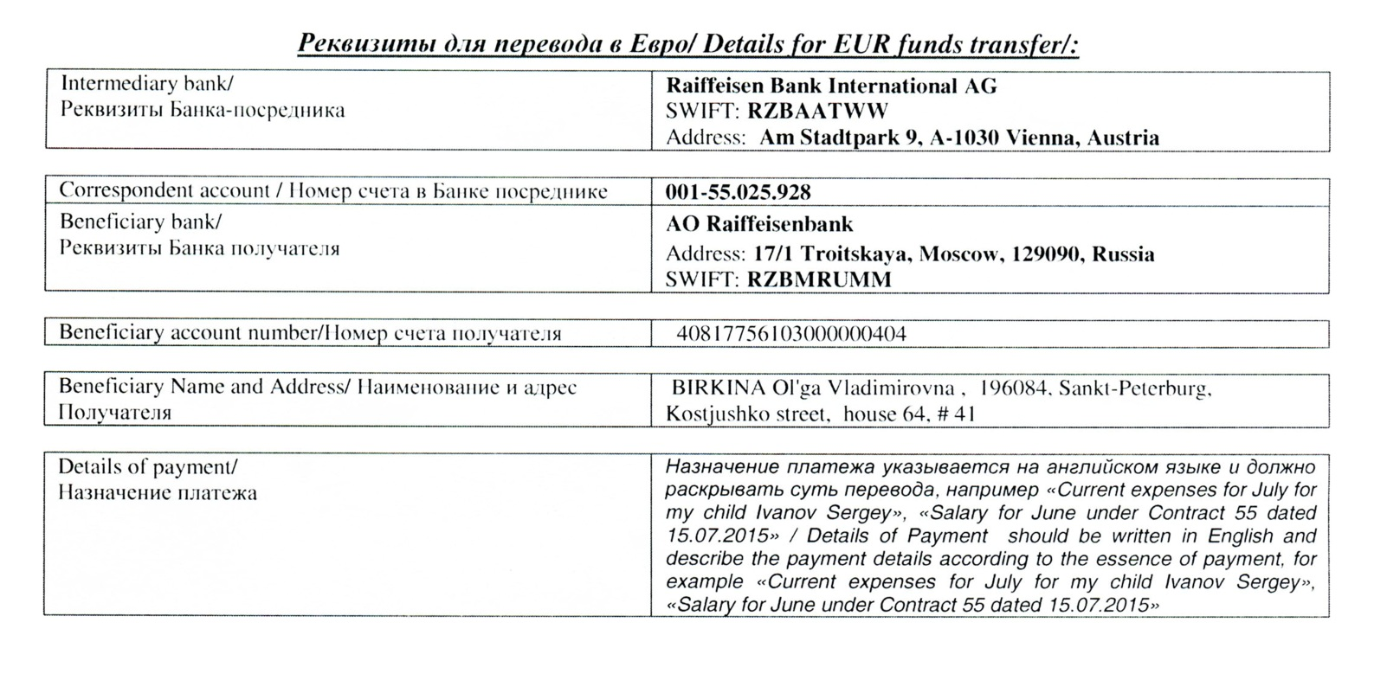
REQUISITES

