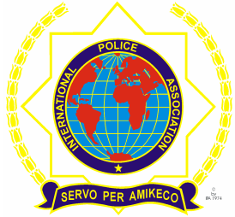 | INTERNATIONAL POLICE ASSOCIATION (IPA)  MOSCOW REGION  www.mosipa.ru
REGISTRATION FORM
«MAYSKAYA» WEEK IN MOSCOW

(08 May – 13 May 2018, Moscow)

SURNAME ……………………. FORENAMES……………………
Address (Including Postcode): ……………………………………………….
National Section: ………………………………..
E-mail address: …………………………………..
Tel.№: …………………………………………
Language: English
X
French
German
Spanish
ACCOMMODATION
Double comfort Suite double comfort
Single comfort Suite single comfort

ARRIVALS/ DEPARTURES
Date & Time of Arrival: ………………….. Airport: ………………..
Date & Time of Departure: ………………….. Airport: ……………….

PRICE PER PERSON:
Double - 995 Euro
Single - 1095 Euro

Signature: ……………………………Date:…………………………………...

The registration form must be completely filled, the reservation has been paid and sent to us (mosipa@mail.ru) before April 15/2018

***The organizers reserve the right to make changes to the program maintaining the quality of services offered.

