Dear National IPA Presidents,
Dear IPA Friends,

The Romanian Section of the International Police Association has the great honor to invite you to attend the event of the

1st INTERNATIONAL POLICE WOMEN’S MEETING
„DANUBE DELTA 2017” – ROMANIA
JUNE 21 - 26, 2017

Event organized by IPA Romania, between June 21 - 26, 2017

- The social program includes visiting a unique place in Europe and in the world, the Danube Delta, including a cruise trip on the Danube, and other touristic attractions.
- English language will be the main language used in communication and English translation will be provided during the meeting sessions.
- Further, you will find a brief description of the beautiful places we will be visiting during the Meeting period of 21 to 26of June, 2017.
For a short preview of the main touristic objectives, please visit the links below:
https://www.youtube.com/watch?v=wo6hEEIgChY
https://www.youtube.com/watch?v=_q34jFyXaYE
https://www.youtube.com/watch?v=hNrAWooy1e0
https://www.youtube.com/watch?v=DTVhVpJInfg

What to Expect

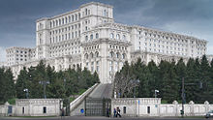
The Palace of the Parliament
(Romanian: Palatul Parlamentului)
is the seat of the Parliament of Romania.
Located on Dealul Arsenalului in central Bucharest (District 5), it is the second-largest administrative building in the world, after The Pentagon in the United States. With a height of 84 m, an area of 365,000 m² and having a volume of 2,550,000 m³, it is also the fourth biggest building in the world, after the Vehicle Assembly Building at Kennedy Space Center in Florida and the Temple of the Feathered Serpent in Teotihuacan, Mexico, and The Pentagon. In terms of weight, the Palace of the Parliament is the heaviest building in the world, weighing in at around 4,098,500,000 kg.
A colossal parliament building known for its ornate interior composed of 23 sections, it houses the Senate and the Chamber of Deputies, three museums and an international conference center. The National Museum of Contemporary Art, the Museum of Communist Totalitarianism (established in 2015) and the Museum of the Palace are hosted inside the Palace. Though named the House of the Republic (Romanian: Casa Republicii), after the Romanian Revolution in 1989 it became widely known as the People's House (Romanian: Casa Poporului). Due to its impressive endowments, conferences, symposiums and other events are organised by state institutions and international bodies, but even so about 70% of the building is empty.
In 1990, Australian business magnate Rupert Murdoch wanted to buy the building for US$1 billion, but his bid was rejected. As of 2008, the Palace of the Parliament is valued at €3 billion ($3.4 billion), making it the most expensive administrative building in the world. The cost of heating and electric lighting alone exceeds $6 million per year, as much as a medium-sized city.

The Danube Delta
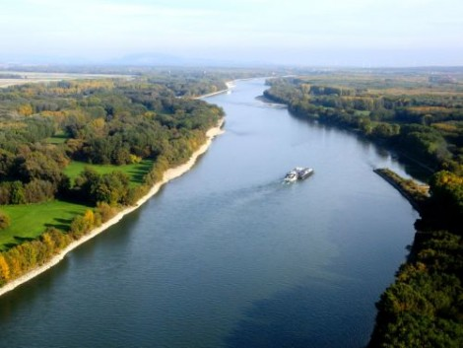
The mighty Danube River flows 1,788 miles from its springs in Germany's Black Forest to the Black Sea. Just before reaching the sea it forms the second largest and best preserved of Europe's deltas: 2,200 square miles of rivers, canals, marshes, tree-fringed lakes and reed islands. After passing through several countries (Germany, Austria, Slovakia, Hungary, Croatia, Serbia, Bulgaria, Moldova, Ukraine and Romania), the mighty Danube river empties into the Black Sea, in a myriad of shades and unforgettable sunsets.
The waters of the Danube form the largest and best preserved of Europe’s deltas. It is the newest land of Romania, it is an untouched land of beauty, nature and wilderness.
The Danube Delta is a wildlife enthusiast's (especially a bird watcher's) paradise.
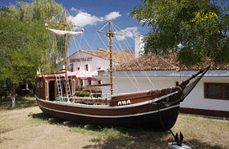China and Africa. Millions of Egyptian white pelicans arrive here every spring to raise their young, while equal numbers of Arctic geese come here to escape the harsh winters of Northern Europe.
Travelers can spend three or more days exploring its passages, teaming with the highest concentration of bird colonies in all of Europe. The maze of canals bordered by thatch, willows and oaks entangled in lianas, offers the perfect breeding ground for countless species of birds, some of them from as far away as
Some 300 species of birds make Danube's Delta their home, including cormorants, white tailed eagles and glossy ibises. The bird watching season lasts from early spring to late summer. Birds are not the only inhabitants of the Delta. There is also a rich community of fish and animals; from wildcats, foxes and wolves, to even an occasional boar or deer. Altogether, 3,450 animal species can be seen here, as well as 1,700 plant species.
The Danube Delta, included on Unesco’s World Heritage list, is one of Romania’s leading tourist attractions. But these are just words. Because the Delta has been visited by just 20% of Romanians and very few foreign tourists. Why? People don’t know what to do there...
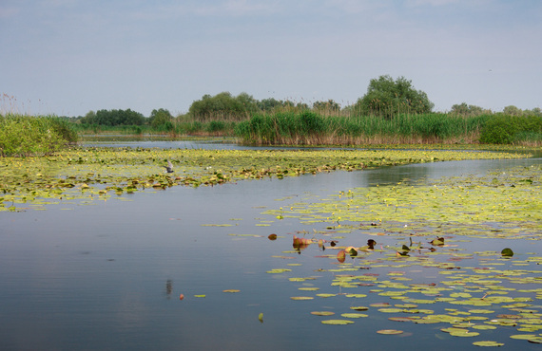
The road to this amazing destination is easy, short and authentic. From the airport you will reach the Capital, Bucharest, and from there there are buses, trains and even taxis that will bring you to the shores of the Danube, in Tulcea County. You will find accommodation in less than 6 hours after landing.
On the river there are hotels, guesthouses and floating hotels that are expecting you with traditional food, intense silence, a sea of green, forests, gardens and weeping willows. Every hotel has boats and floating pontoons, ready to transform your holiday into the best adventure of your life. The delta is a haven for wildlife lovers, birdwatchers, fishers and anyone wanting to get away from it all for a few days. But a few days can always turn into in a week, and then into a love story for a lifetime.
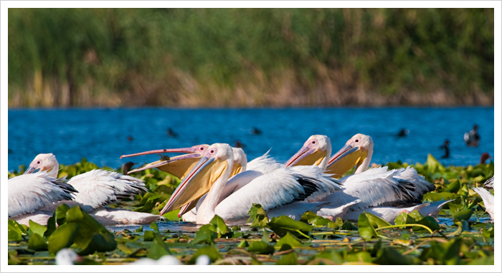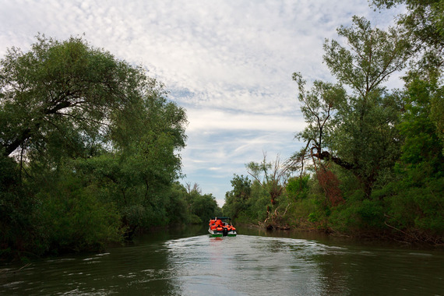
Over 300 species of birds have houses here, in this untouched land, of which over 176 species breed, the most important being cormorant, pygmy cormorant, white pelican and Dalmatian pelican. There are numerous multi-species heron colonies and raptor species including the white-tailed eagle. The delta is very rich in fish, with 45 fresh water species present. Otter and weasel are to be found on the floating islands.

Once you are there, in the middle of wilderness, what can you do?
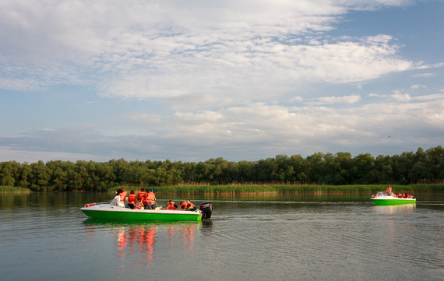
1. Relax in a space of pure nature, in silence and meditation.

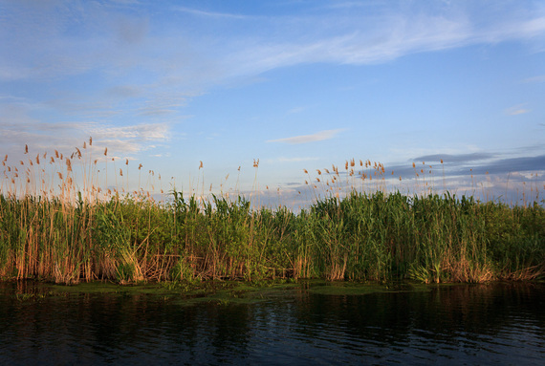
2. Listen to the wind and waves of the green river.

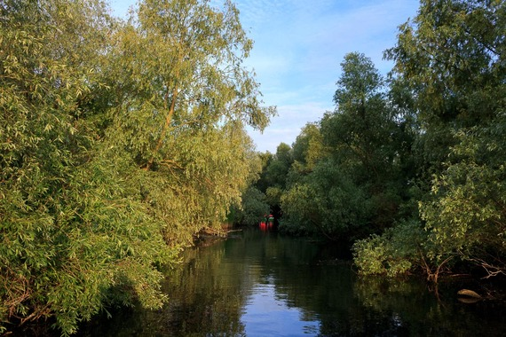
3. Take some amazing photos with nobody between you and Mother Nature.

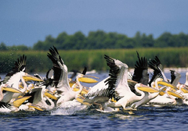
4. Birds watching.
There are hundreds of beautiful birds in their natural habitat: pelicans, cormorant, swans, and many others. It’s delightful to see these birds fishing in the huge lakes of the Danube Delta.
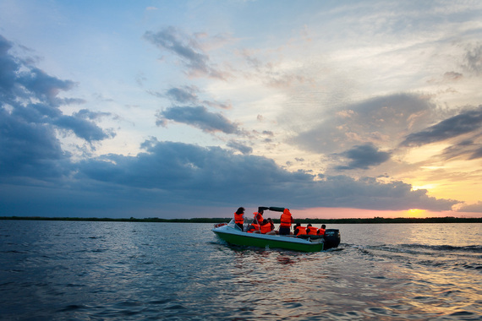
5. Boat Ride. You can rent a boat or just let the hotels’ owners to help you and give you a ride on the Danube canals. At the sunset, in the morning, all day long.

2.
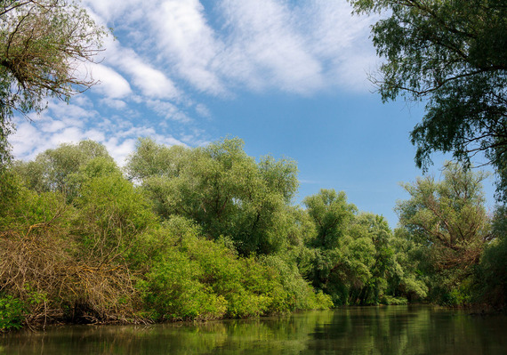
6. Breathe fresh air, get a tan, listen to the wind and feel the weeping willows.

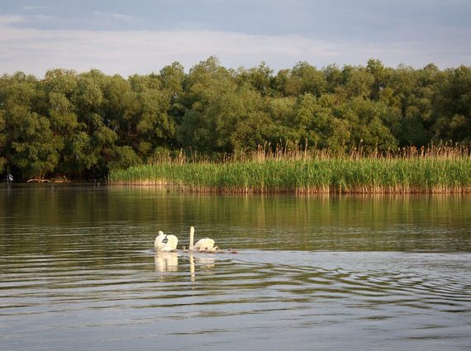
7. Have a contest with your friends and family: who will see the most amazing bird?

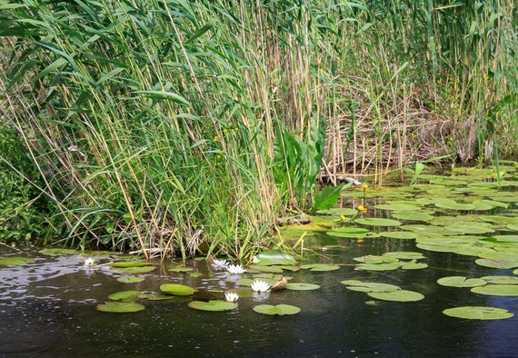
8. Make spectacular photographs with white and yellow water lilies.

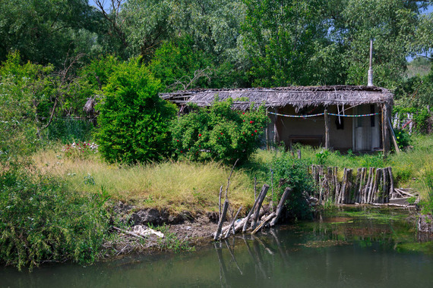
9. Visit atemporal villages. Relax in a hammock all day long and listen to the locals’ stories.

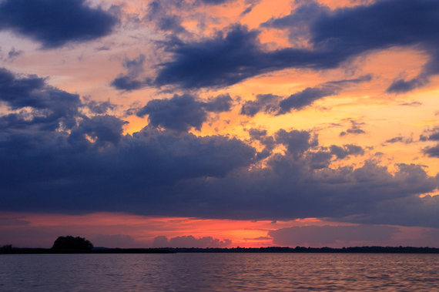
10. Navigate deep into the canals to feel the sunsets.

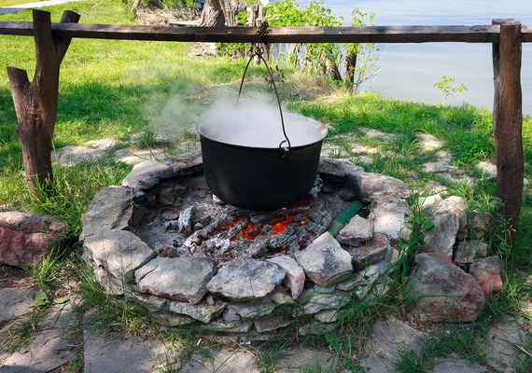
11. Eat fish soup and fish grill, and some other traditional Romanian food.

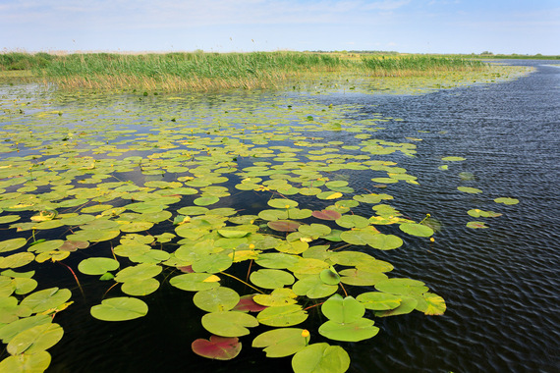
12. Read a book about the Danube Delta, listen to some traditional music, drink a very good Romanian wine and share some stories with your friends.

The Danube Delta is not for everybody. It is a quiet space, an open, light and wild space, full of life and miracles. Life on the river is sometimes hard, but really worth it. Do you want to have such an adventure? We think you have the best reason. If you are an explorer, you will enjoy it tremendously: locals’ stories, the wilderness, and the silence that seeps through the willows.

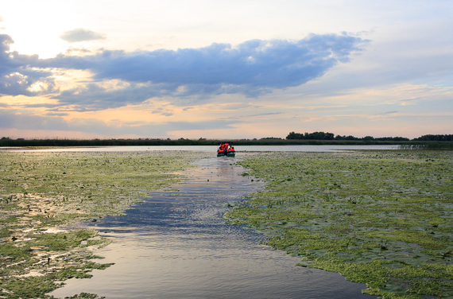

New HOTEL EGRETA

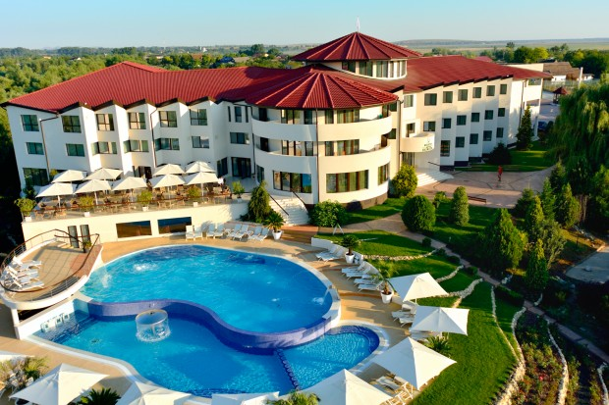
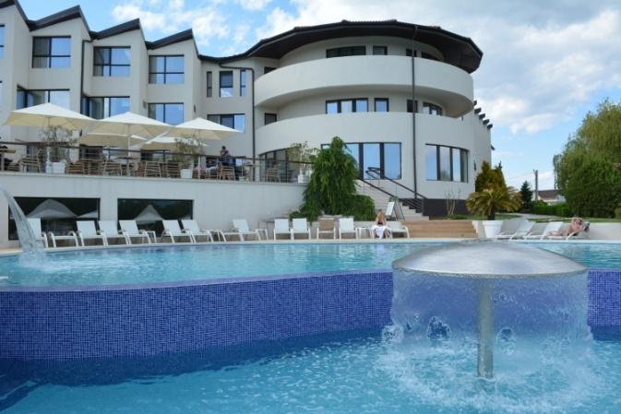
We will present you a lifetime adventure and another kind of holiday for those who love to discover new lands, nature, secluded villages, history, culture, amazing people, great food, art and entertainment, sea, mountains, cities, architecture, music and fashion, old churches and secret destinations of the world. All of these in just one place, in one country: Romania. Follow us in our adventure, and you will read our stories, enjoy our photos and you will travel with us in our beloved country.
And you know what? Maybe it’s time to visit Romania! Here is why...

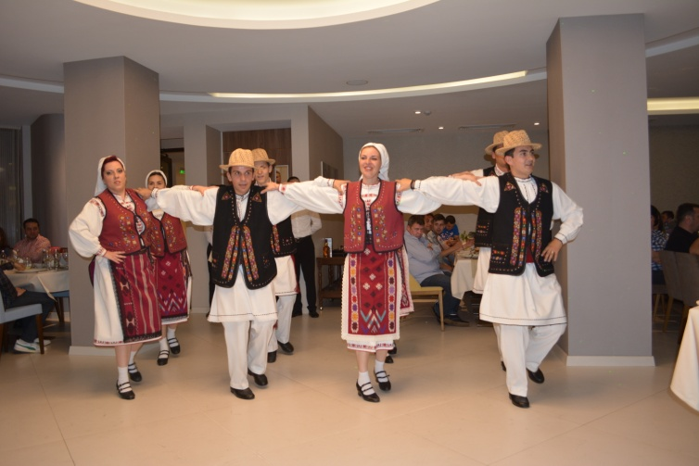
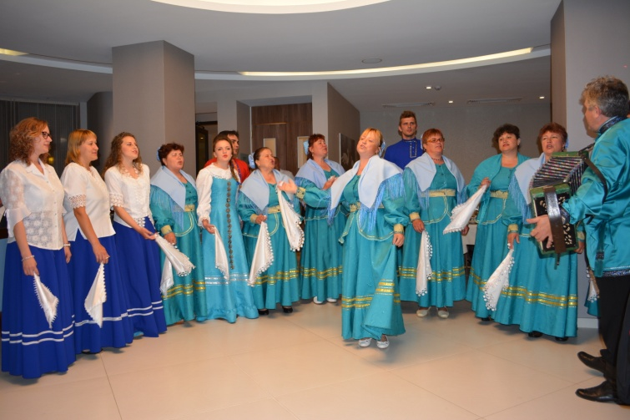

1st INTERNATIONAL POLICE WOMEN’S MEETING
„DANUBE DELTA 2017” – ROMANIA
JUNE 21 - 26, 2017

APPLICATION FORM

- The arrivals and the departures for the event will be made on Otopeni Airport-Bucharest

Name: _____________________________Surname:______________________________________
Delegate□ Other□
Tel:__________________________________ E-mail______________________________________
IPA Section ____________________________Country:____________________________________
ARRIVAL: (X) Car____Flight_____Train_______Bus______Other_____
Date:_________________________________ Time:____ :______
Flight:________________________________ Airline:___________________________________
Accomodation: Single (__)
Double (__) twin / double (__)
Sharing with:______________________________________________________________________
DEPARTURE:
Date:_________________________________ Time:____ :______
Flight:________________________________ Airline:___________________________________
Shirt size: S□ M□ L □ XL□ XXL□
Date: ___________________ Signature:__________________________________
The application forms, together with the confirmation of payment are to be submitted by electronic mail to: c.marin@iparomania.ro by May 1, 2017 at the latest.
PAYMENT DETAILS

June 21 - 26, 2017
Prices:
Doube room 295,00 € per person
Single room 335,00 € per person
Fares include: - Transfer from Otopeni Airport to the HELLO Hotel
- Accomodation at HELLO Hotel, Bucharest and NEW HOTEL EGRETA, Tulcea.
- Meals
- Conference program
- Entry tickets to MACIN VINERY, PARLIAMENT HOUSE, cruise to the DANUBE DELTA
- Transportation by bus to Tulcea and back
- Sightseeing passes to main touristic attractions in Bucharest and Tulcea.
Method of payment: Bank transfer
BANK ACCOUNT DETAILS
Account Name: ASOCIAŢIA INTERNAŢIONALA A POLIŢIŞTILOR SECTIA ROMANA IBAN: RO15BPOS85002717812EUR01
Bank Swift Code: BPOS ROBU
Bank name: : BANCPOST S.A. SUCURSALA LIBERTATII
Address: Bld. Libertatii, nr.20, Bl.103, Sc.A, Sector 5, Bucureşti, 050707
The application forms, together with the confirmation of payment are to be submitted by electronic mail to: c.marin@iparomania.ro by May 1, 2017 at the latest.
Refunds will not be possible for cancellation requests submitted after this date.
The Romanian Section is bound to acknowledge receipt of the application form and the participation payment.
For additional information, please email c.marin@iparomania.ro

<< We will experience an unforgettable tour of the unique Danube Delta >>

1st INTERNATIONAL POLICE WOMEN’S MEETING
„DANUBE DELTA 2017” – ROMANIA
JUNE 21 - 26, 2017

PROGRAMME

Wednesday Arrival of delegates & guests and transfer to the HELLO Hotel
21.06.2017
19.00-20.00 Bucharest City Tour
20.00 Dinner at the Brewery H Pub

Thursday
22.06.2017
07.00-09.00 Breakfast (check-out)
09.00-10.00 Transportation by bus to Parliament House
10.00-12.00 Sightseeing tour of Parliament House
12.00-15.00 Transportation by bus to MacinVinary
15.00-17.00 Wine tasting and lunch
17.00-19.00 Transportation by bus to the Danube Delta
20.00-22.00 Dinner at New Hotel Egreta

Friday
23.06.2017
08.00-10.00 Breakfast
10.00-11.30 Meeting session (official presentation of the Danube Delta made
by the Deputy Governor of the Danube Delta)
11.30-11.45 Coffee break
11.45-12.45 Meeting session
12.45-13.00 Official photograph
13.00-14.30 Lunch
14.30-20.00 Free program
20.00 Dinner at New Hotel Egreta
Artistic show performed by ,,Baladele Deltei” Artistic Assembly
Saturday
24.06.2017
08.00-10.00 Breakfast
10.00-13.00 Cruise to the Danube Delta
13.00-14.30 Lunch
14.30-20.00 Free program (swimming, bowling, etc)
20.00 Official dinner party

Sunday
25.06.2017
08.00-10.00 Breakfast
10.00-13.00 Free program
13.00-13.30 Check-out
13.00 Transportation by bus to HELLO Hotel – Bucharest
19.00-21.00 Dinner at EXCELSIOR RESTAURANT

Monday
26.06.2017
08.00-10.00 Breakfast
- Check-out and departures

<< Family members and friends of the delegates are welcome
to attend the meeting! >>

