THE PROGRAMM
Friendship week in MOSCOW «Spasskaya Tower»
for 27 August - 02 September 2018
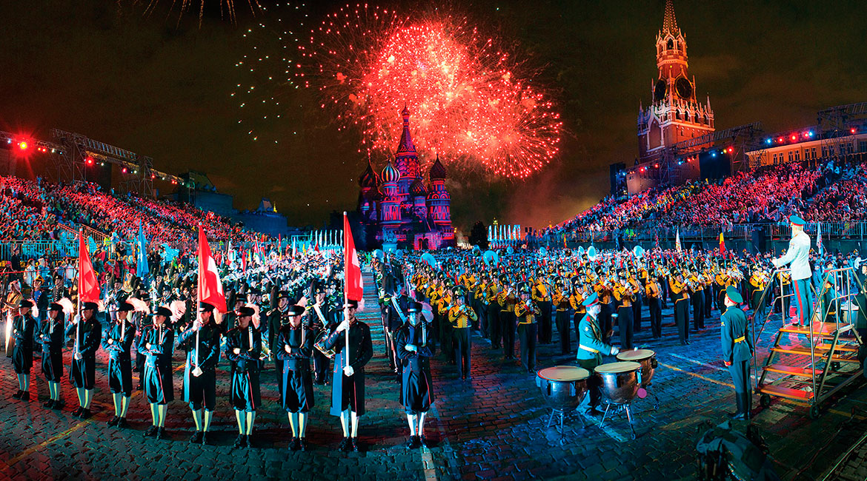
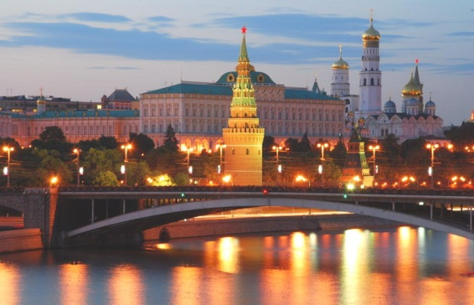
27th of August, Monday
• Meeting at the Airport
- Arriving at the Hotel
- Dinner
- Evening walk by Moscow

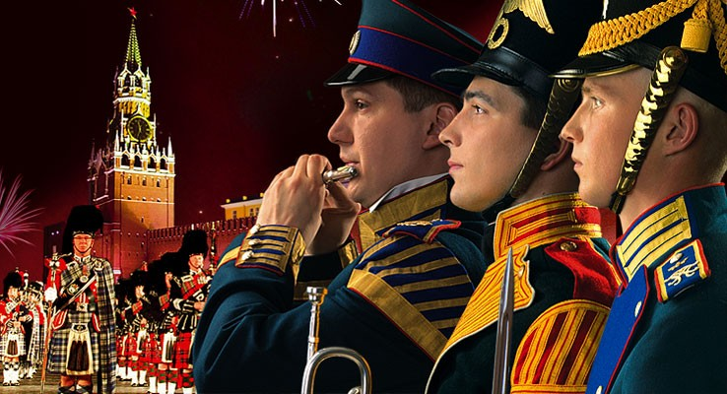
28th of August, Tuesday
- Breakfast
- Visit to the police stations
- Lunch
- Dinner
- The Festival Spasskaya Tower

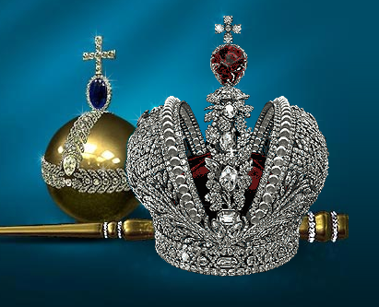
29th of August, Wednesday
- Breakfast
- The Diamond Fund, The Armory Museum, The Kremlin
- Lunch
- The Zaryadye Park
- Free time
- Dinner

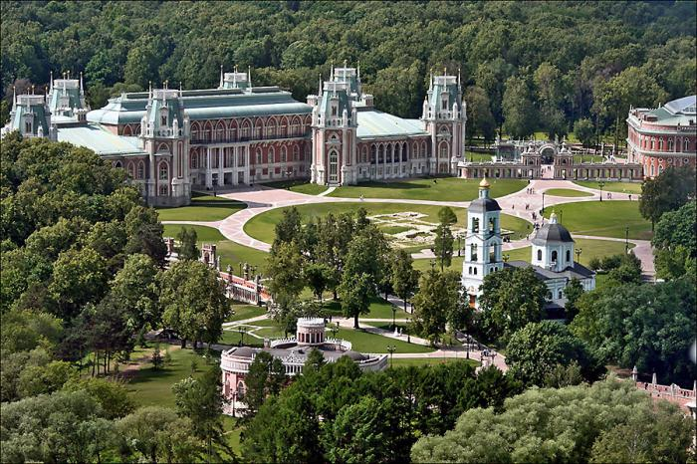
30th of August, Thursday
- Breakfast
- The museum-reserve Tsaritsyno
- Lunch
- Visit to the Office of the Moscow region IPA
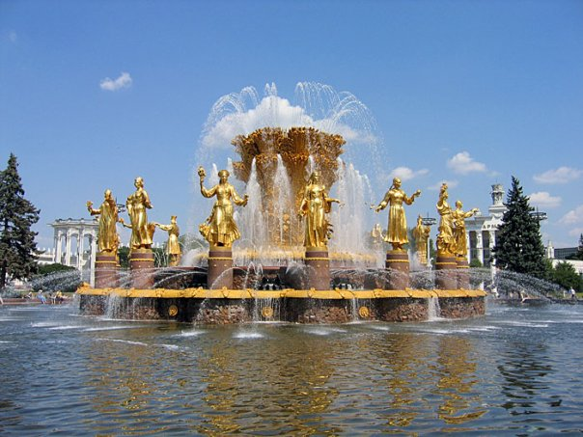
- Dinner

31th of August, Friday
- Breakfast
- VVC All-Union exhibition of achievements
- Lunch
- The Moscow planetarium
- Dinner
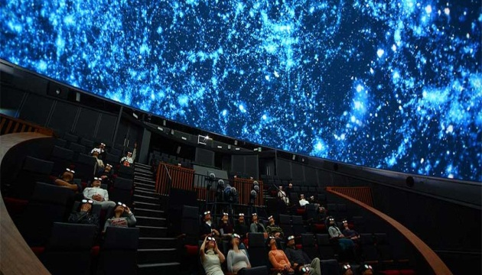

01th of September, Saturday
- Breakfast
- The Museum of Great Patriotic war. The Poklonnaya hill.
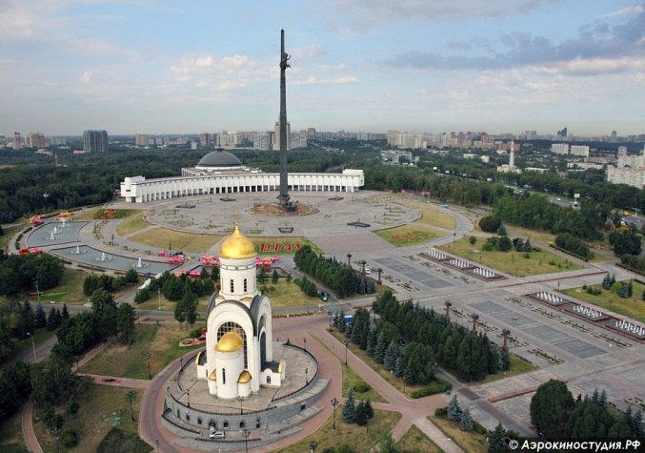
- Museum-panorama "Battle of Borodino "
- Lunch
- Free time
- Gala dinner

02th of September, Sunday

- Breakfast
- Transfer to the Airport

*The organizers reserve the right to make changes to the program, maintaining the quality of services offered.

