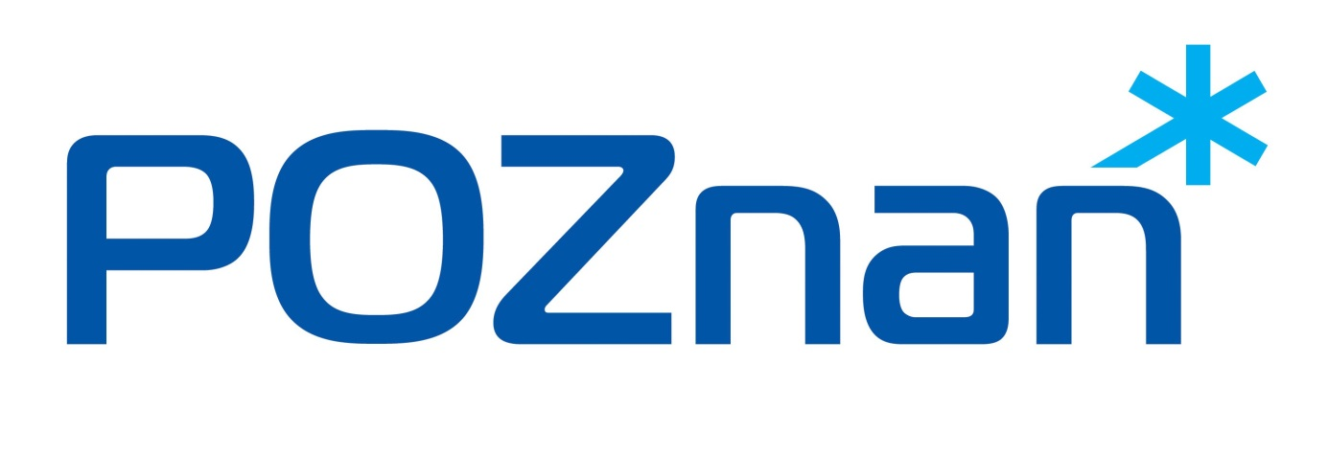
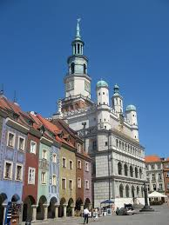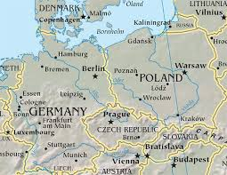
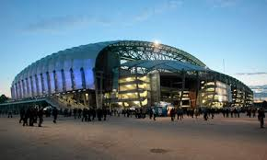

XIX International Football Tournament IPA Poznań 2017

Region IPA Poznań would like to invite you to participate in a football tournament of XIX International Football Tournament IPA Poznań 2017.
Tournament date - 24.08.2017 - 27.08.2017
Participation fees:
- participation fee for each team - 100 EUR
- total participation fee for each contestant - 100 EUR (includes accommodation, food, banquet).
Accident insurance is each players individual business (host has third party liability insurance).
- Accommodation:
DS Zbyszko / Jagienka , Poznań ul. Piątkowska 38
(about 2km from city centre).
Rooms for 2 - persons with sanitary,
Tournament pitch - syntetic grass, teams of 6+1 (with a max total number of registered players - 12).
Application filled on enclosed form should be sent by 25 may 2017 on e.mail address - witold.ipa@wp.pl
By application day, each team should transfer team participation fee on IPA Poznan account - PL 38102040270000120203209087, SWIT: BPKOPLPW
The rest of the fees should be paid by 15.06.2017 (there is a possibility to pay host by cash after arrival, after earlier confirmation with tournament host).
Tournament rules of play will be send to each interested team after registration.
On the end of the tournament each team will a be rewarded with cup and diploma. There will be also prize for the best goalkeeper of the tournament and the best scorer of the tournament.

IPA POZNAN

Application form
Team name -
Number of players -
Contact person -
Team participation fee was transferred on the date of____________
Total number of people arriving on the tournament

_______________________________
Signed

