Nottinghamshire UK Branch 60th Anniversary Celebration
@ National Water Sports Centre
Holme PierrepontCountry Park.
Nottingham NG12 2LU
7th to 11th June 2018.
Join us in the heart of England to
celebrate our anniversary

Programme
£115 per guest covers the cost for the following programme.
Date | Time | Activity
Thursday 7th June 2018 | 15:00-16:00 | Guest arriving early optional tour of Nottingham Forest Football Ground and Nottingham Trent Bridge Cricket Ground
 | 16:00-18:00 | Welcome Guests at the IPA International H.Q. Fox Road, West Bridgford, Nottingham NG2 6AJ. Refreshments provided.
Friday 8th June 2018 | 10.30-12:00 | Official opening of IPA festival by Nottinghamshire Police Chief Constable Craig Guildford followed by a tour of Nottinghamshire Police headquarters.
 | 12:30-14:00 | Traditional English afternoon tea at a country restaurant- The Lakeside.
 | 14:00- 17:30 | Coach trip to an English stately home – Newstead Abbey.
 | 19:00- 21:30 | Buffet evening meal in Nottingham, at Cosmos- a restaurant which caters for all tastes.
Saturday 9th June 2018 | 09:30-14:30 | Take a local bus to the city centre where you may visit Nottingham Castle, the Robin Hood Statue, visit the oldest pub in England, the Trip to Jerusalem built in 1179 and the Old Market Square.
 | 15:00-16:00 | Optional activity at guests own cost; Segway or canoeing at Holme Pierrepont, or stay in Nottingham for great shopping.
 | 19:00-23:00 | A meal and social at a traditional English pub, The Lady Bay in West Bridgford,
Sunday 10th June 2018 | 09:30- 16:00 | Coach trip to the historic town of Newark-on- Trent. Followed by a visit to Southwell with its medieval Minster church. Lunch at guests own cost.
 | 19:00-late | Dinner & Dance at the Belgrave Rooms, Nottingham. Exchange of Branch gifts. Closure of the Festival by the Chief Constable.
Monday 11th June 2018 |  | Guests depart

Accommodation. Holme Pierrepont has 34 single rooms. Weekday £46. Weekend £56 and
20 twin rooms. Weekday £66. Weekend £76. Free use of gym/wifi/parking.
Holme Pierrepont camping site: £14 per pitch with electric. For more info: www.nwscnotts.com
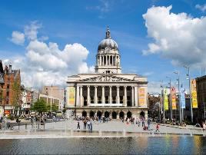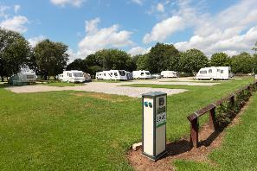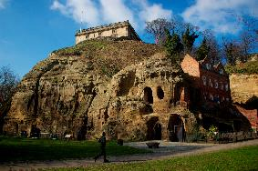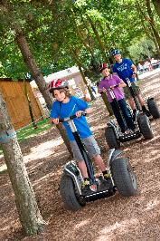
Application form to be completed for each IPA member attending.
Name……………………………………………………………………………………………………
Address…………………………………………………………………………………………………
Date of Birth……………………………………………………………………………………………
Tel No…………………………………………………………………………………………………..
Email …………………………………………………………………………………………………..
IPA branch ……………………………………… IPA member no…………………………………
Names of others attending with IPA member:
…………………………………………………………………………………………………………………….………………………………………………………………………………………
Please tick what type of accommodation/optional activity you require.
Accommodation required at Holme Pierrepont Full English breakfast included.
Free use of gym, wifi and parking
Thursday 7th June | Single £46 per room | Twin £66 per room | Please note- beds do not join up to make double
Friday 8th June | Single £56 | Twin £76
Saturday 9th June | Single £56 | Twin £76
Sunday 10th June | Single £46 | Twin £66

Holme Pierrepont camping site: £14 per pitch with electric
Thursday 7th June | £14
Friday 8th June | £14
Saturday 9th June | £14
Sunday 10th June | £14
Canoeing 9th June (optional) | £5.00 One person Kayak for 30 minutes
Segway 9th June (optional) | £7.50 for 20 minutes on our purpose-built track
Programme activities | £115
Total to pay

Please make payment to IPA Nottinghamshire Branch
Account No: 50257852 sort code: 050622 reference: Notts IPA 60th
For International guest please use IBAN number GB29YORK05062250257852
Please submit your form by 31st January 2018
to
Jaspreet Athwal nottingham@ipa-uk.org

