Devon Branch IPA Spring Friendship Weekend 2020
Friday 14 February to Monday 17 February 2020

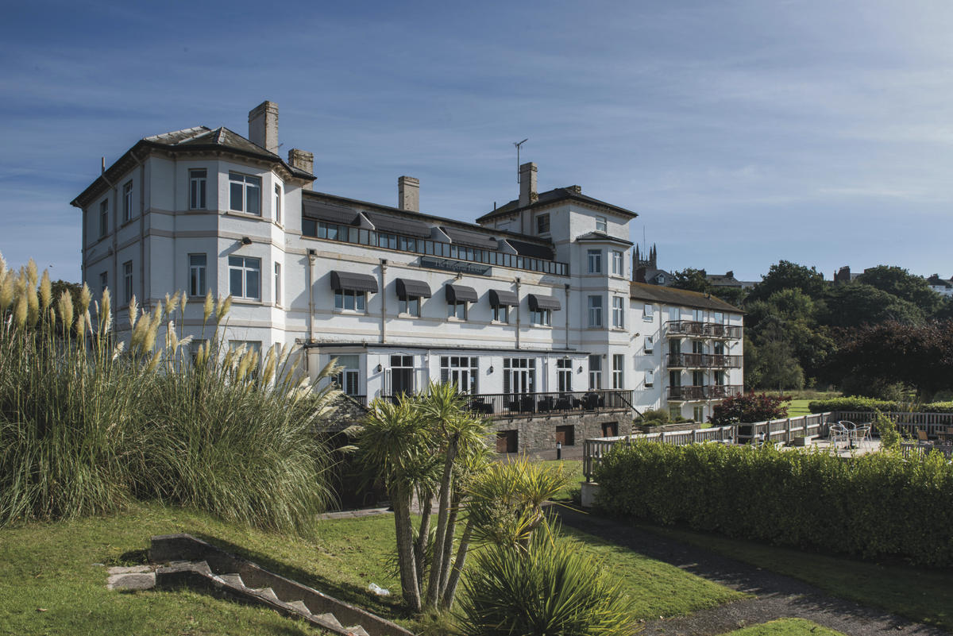

For next year’s weekend, we have reserved rooms at the Imperial Hotel at Exmouth, a venue that we have all enjoyed in the past. The hotel is one of Shearings’ “Coast and Country” hotels and has a Trip advisor certificate of excellence. For further details of the hotel, and lots of photos, please click here: https://www.shearings.com/hotels/imperial-exmouth-hotel
The rate we have negotiated is £49.50 per person per night based on a standard double or twin, with Dinner Bed and Breakfast and VAT inclusive.

Extras you can choose are:

- Standard Sea View: £7 per person per night
- Standard Plus: £5 per person per night
- Standard Plus, sea view: £12 per person per night
- Superior sea view: £19.50 per person per night

To book for the 2020 break, call Shearings on +44 3444 129013 quoting the reference:
IPA Springbreak GA000129.

On booking, you pay £45 per person deposit, with the remaining balance to be paid 6 weeks in advance.

If you have any questions, Owen Harris
owen.r.harris@live.co.uk

Una Blundell
u.blundell@btinternet.com

We look forward to seeing you in Glorious Devon in 2020!

